**Access to SQL Server**

Download SQL Server Management Studio (SSMS)

<https://aka.ms/ssmsfullsetup>

This is main database for XPPL Web Application (IP: 192.168.9.243)

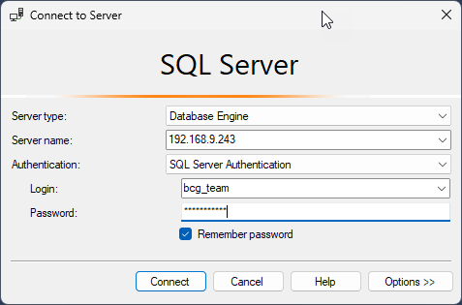

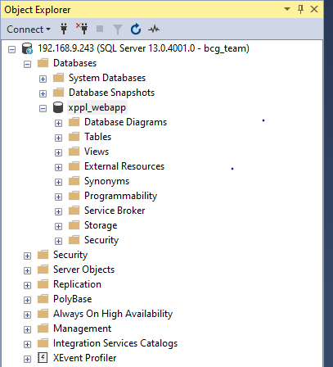

This is Weighbridge database (IP: 192.168.9.20.1434)

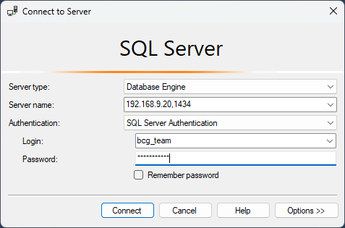

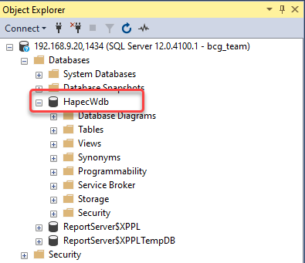

This is Geology Department database (IP: 192.168.9.6)

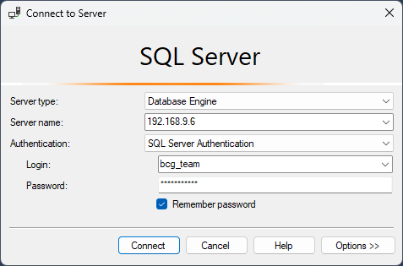

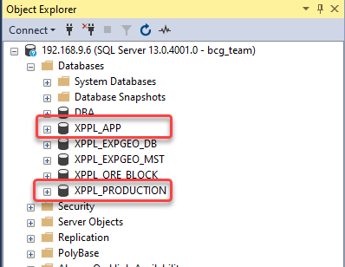

1. XPPL_APP: The database for web app ip: 101.78.11.14:844
2. XPPL_PRODUCTION: Mined production data from Geology dept.